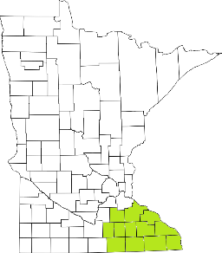Collaborative Resources Education Services Technology
(CREST)
Regional Management Team Agenda
November 10th at 1-3:00 PM

- Welcome
- SERCC/mobile crisis updates
- Suicide Prevention work
  - MDH workgroup
- Data Reports
  - Direct Care and Treatment
  - MHIS reports
- Strategic Planning Goals
- Budget
  - Grant management Documents
- DHS AMHI reform updates

Next meeting scheduled for February 9th, 2022

